**1. INTRODUCTION**

Student Management System is software which is helpful for students as well as the school authorities. In the current system all the activities are done manually. It is very time consuming and costly. Our Student Management System deals with the various activities related to the students.

There are mainly 3 modules in this software

* Admin module
* Student Module

In the Software we can register as a user and user has of two types, student and administrator. Administrator has the power to add new user and can edit and delete a user. The administrator can add edit and delete marks for the student. All the users can see the marks.

**2. Problem Definition**

Student Management System is software which is helpful for students as well as the school authorities. In the current system all the activities are done manually. It is very time consuming and costly . It is improper to Manage files and student record Manually

This leads data improper format.WeCant Access the student record from the file for each student they had to check file every time.There is an security issues are comes to file . The Student Management System helps to manage the data more efficiently and save the time.

**3. EXISTING SYSTEM**

System Analysis is a detailed study of the various operations performed by a system and their relationships within and outside of the system. Here the key question is- what all problems exist in the present system? What must be done to solve the problem? Analysis begins when a user or manager begins a study of the program using existing system.

During analysis, data collected on the various files, decision points and transactions handled by the present system. In the current system all the activities are done manually. It is very time consuming and costly . It is improper to manage files and student record Manually

This leads data improper format .Wecan’t Access the student record from the file for each student they had to check file every time. There is an security issues are comes to file . The Student Management System helps to manage the data more efficiently and save the time.

**4.PROPOSED SYSTEM**

In our proposed system we have the provision for adding the details of the students by themselves. So the overhead of the school authorities and the teachers is become less. Another advantage of the system is that it is very easy to edit the details of the student and delete a student when it found unnecessary. The marks of the student are added in the database and so students can also view the marks whenever they want.

Our proposed system has several advantages

* User friendly interface
* Fast access to database
* Less error
* More Storage Capacity
* Search facility
* Look and Feel Environment
* Quick transaction

All the manual difficulties in managing the student details in a school or college have been rectified by implementing computerization.

**5. Feasibility Study**

**Technical Feasibility:**

We can strongly says that it is technically feasible, since there will not be much difficulty in getting required resources for the development and maintaining the system as well. All the resources needed for the development of the software as well as the maintenance of the same is available in the organization here we are utilizing the resources which are available already.

**Economical Feasibility:**

Development of this application is highly economically feasible .The organization needed not spend much money for the development of t he system already available. The only thing is to be done is making an environment for the development with an effective supervision. I f we are doing so , we can attain the maximum usability of the corresponding resources .Even after the development , the organization will not be in condition to invest more in t he organization .There fore , the system is economically feasible.

**6. Hardware and software Requirements.**

The most common set of requirements defined by any operating system or system

Application is the physical computer resources also known as hardware requirements

The hardware requirements for this project are:-

* Processor: core i5
* RAM:8GB
* Hard Disk:80GB

Software requirements deal with defining software resources requirements for pre

Requisites The software requirements required for this project are:

* Front End Tool: Java
* Back End Tool:Postgresql
* Development Linux
* Documentation Tool: Microsoft Word 2007
* Design Tool:

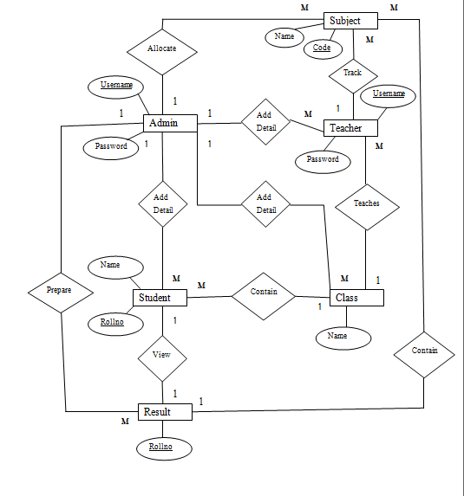 **7. ER Diagram**

**7. UML Diagrams:**

1

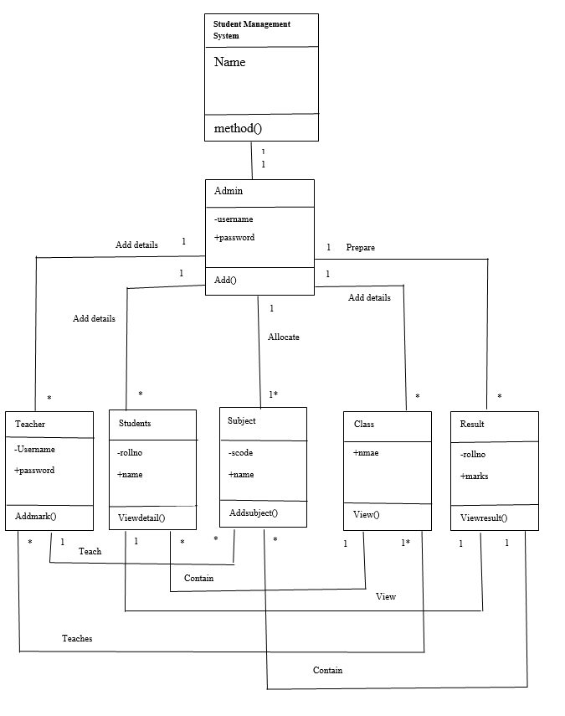7.1. Class Diagram

7.2.Use Case Diagram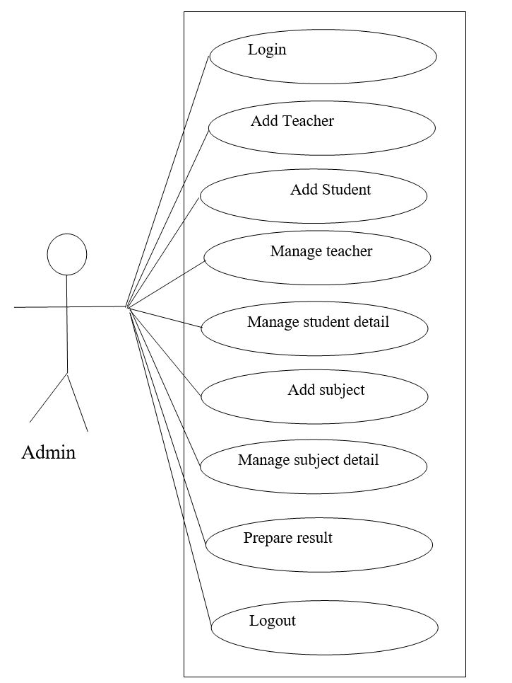

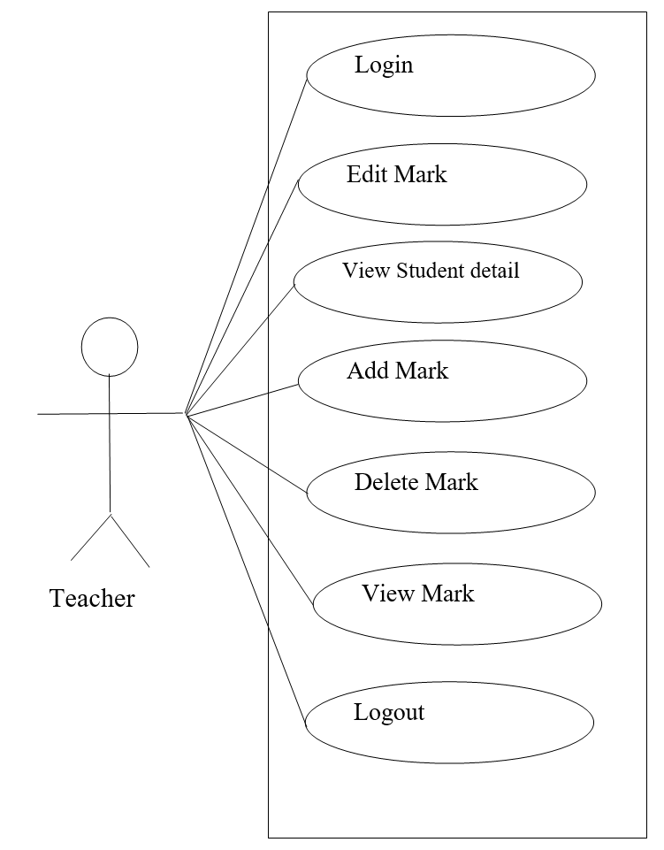

7.3. Sequence Diagram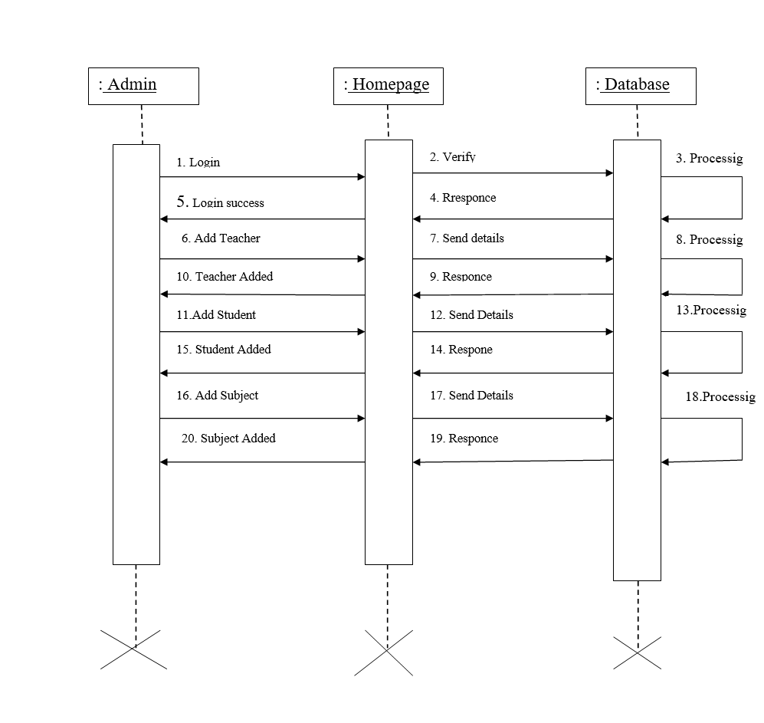

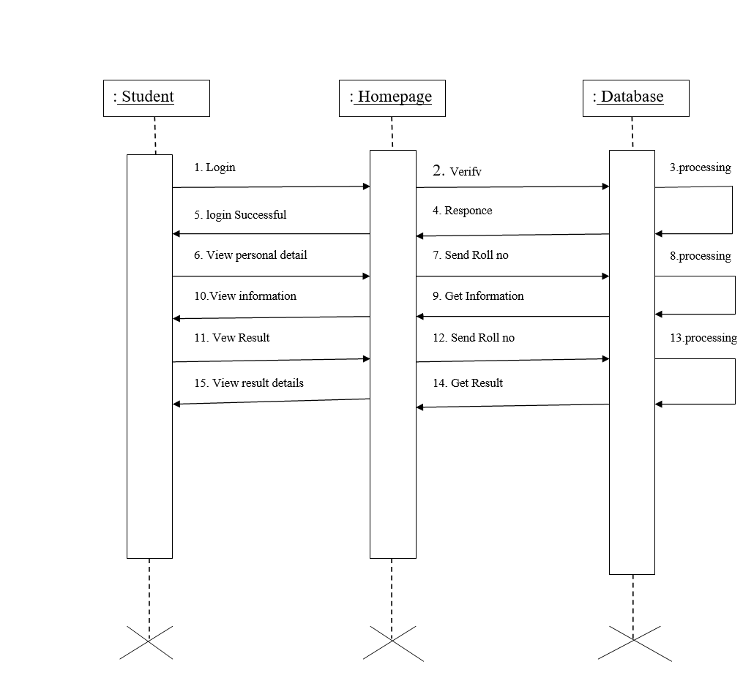

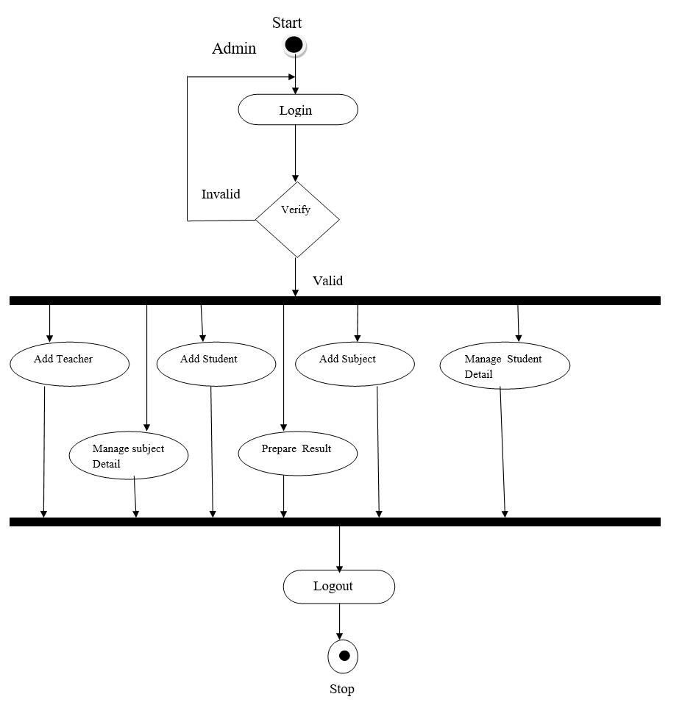7.4. Activity Diagram

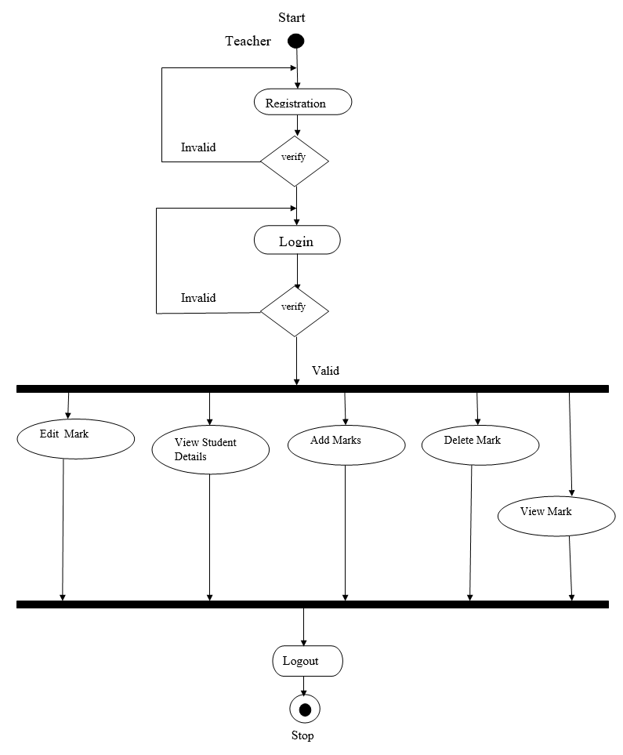

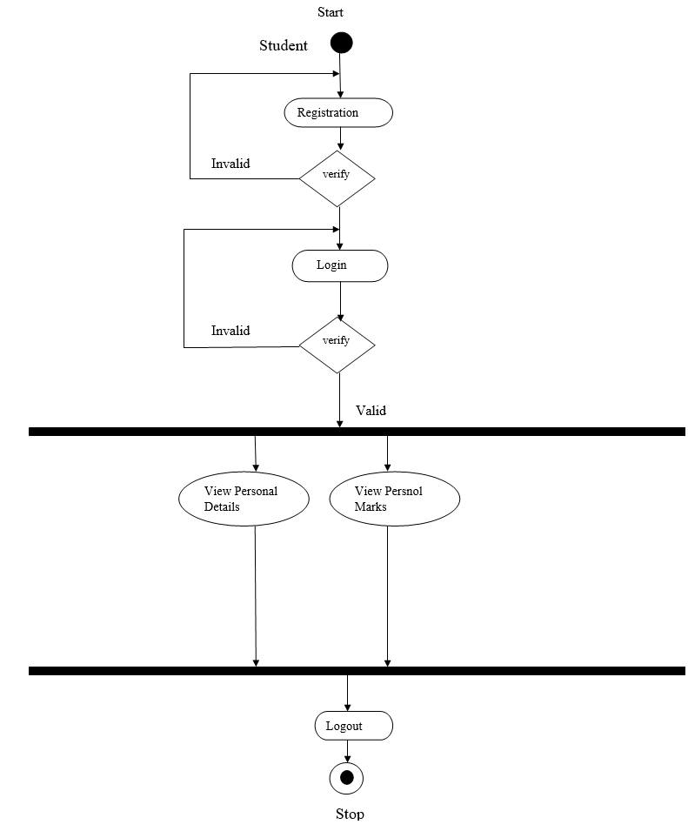

7.5. Component Diagram: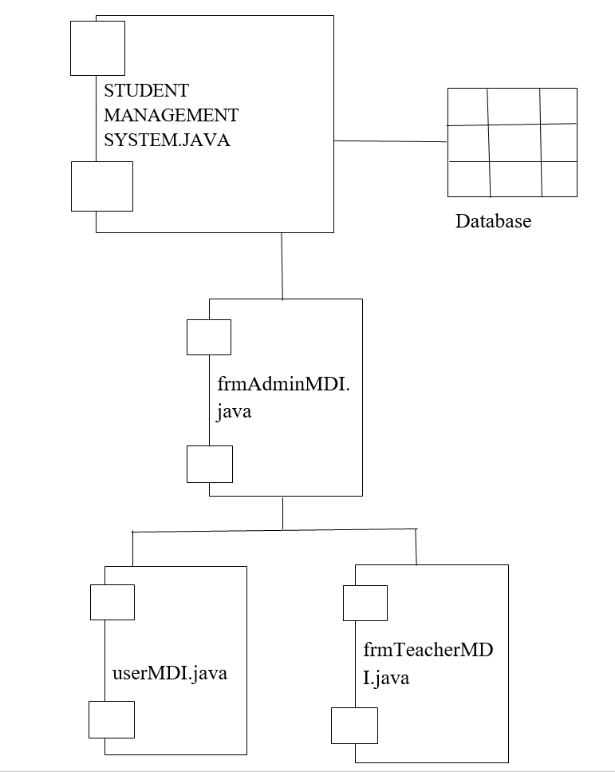

**8.DataDictionary**

Student

|  |  |  |
| --- | --- | --- |
| **Field Name** | **Data Type** | **Description** |
| RollNo | Numeric | Primary Key |
| SName | Text(50) | - |
| Phno | Text(15) | - |
| Sex | Text(10) | - |
| FName | Text(50) | - |
| Occupation | Text(50) | - |
| MName | Text(50) | - |
| DOB | Text(50) | - |
| Age | Numeric | - |
| Caste | Text(25) | - |
| Religion | Text(30) | - |
| Hname | Text(50) | - |
| City | Text(50) | - |
| District | Text(50) | - |
| State | Text(50) | - |
| Pin | Text(10) | - |
| Year | Numeric | - |
| Qualification | Text(25) | - |

UAD

|  |  |  |
| --- | --- | --- |
| **Field Name** | **Data Type** | **Description** |
| Username | Text(25) | Primary Key |
| Password | Text(15) | - |
| Type | Text(15) | - |

Subjects

|  |  |  |
| --- | --- | --- |
| **Field Name** | **Data Type** | **Description** |
| Subjectcode | Text(10) | Primary Key |
| Subjectname | Text(50) | - |
| Creditmark | Number | - |
| MaxMark | Number | - |
| Type | Text(25) | - |

SubjectAllocation

|  |  |  |
| --- | --- | --- |
| **Field Name** | **Data Type** | **Description** |
| Subjectname | Text(50) | - |
| Semester | Number | - |
| Batch | Text(15) | - |

SSLC1

|  |  |  |
| --- | --- | --- |
| **Field Name** | **Data Type** | **Description** |
| RollNo | Number | - |
| SubjectName | Text(50) | - |
| Subjectcode | Text(15) | - |
| Internal | Number | - |
| Theory | Number | - |
| Practical | Number | - |
| Total | Number | - |

SSLC2

|  |  |  |
| --- | --- | --- |
| **Field Name** | **Data Type** | **Description** |
| RollNo | Number | - |
| SubjectName | Text(50) | - |
| Subjectcode | Text(15) | - |
| Internal | Number | - |
| Theory | Number | - |
| Practical | Number | - |
| Total | Number | - |

SSLC3

|  |  |  |
| --- | --- | --- |
| **Field Name** | **Data Type** | **Description** |
| RollNo | Number | - |
| SubjectName | Text(50) | - |
| Subjectcode | Text(15) | - |
| Internal | Number | - |
| Theory | Number | - |
| Practical | Number | - |
| Total | Number | - |

**SSLC4**

|  |  |  |
| --- | --- | --- |
| **Field Name** | **Data Type** | **Description** |
| RollNo | Number | - |
| SubjectName | Text(50) | - |
| Subjectcode | Text(15) | - |
| Internal | Number | - |
| Theory | Number | - |
| Practical | Number | - |
| Total | Number | - |

SSLC5

|  |  |  |
| --- | --- | --- |
| **Field Name** | **Data Type** | **Description** |
| RollNo | Number | - |
| SubjectName | Text(50) | - |
| Subjectcode | Text(15) | - |
| Internal | Number | - |
| Theory | Number | - |
| Practical | Number | - |
| Total | Number | - |

SSLC6

|  |  |  |
| --- | --- | --- |
| **Field Name** | **Data Type** | **Description** |
| RollNo | Number | - |
| SubjectName | Text(50) | - |
| Subjectcode | Text(15) | - |
| Internal | Number | - |
| Theory | Number | - |
| Practical | Number | - |
| Total | Number | - |

PLUSTWO1

|  |  |  |
| --- | --- | --- |
| **Field Name** | **Data Type** | **Description** |
| RollNo | Number | - |
| SubjectName | Text(50) | - |
| Subjectcode | Text(15) | - |
| Internal | Number | - |
| Theory | Number | - |
| Practical | Number | - |
| Total | Number | - |

PLUSTWO2

|  |  |  |
| --- | --- | --- |
| **Field Name** | **Data Type** | **Description** |
| RollNo | Number | - |
| SubjectName | Text(50) | - |
| Subjectcode | Text(15) | - |
| Internal | Number | - |
| Theory | Number | - |
| Practical | Number | - |
| Total | Number | - |

PLUSTWO3

|  |  |  |
| --- | --- | --- |
| **Field Name** | **Data Type** | **Description** |
| RollNo | Number | - |
| SubjectName | Text(50) | - |
| Subjectcode | Text(15) | - |
| Internal | Number | - |
| Theory | Number | - |
| Practical | Number | - |
| Total | Number | - |

PLUSTWO4

|  |  |  |
| --- | --- | --- |
| **Field Name** | **Data Type** | **Description** |
| RollNo | Number | - |
| SubjectName | Text(50) | - |
| Subjectcode | Text(15) | - |
| Internal | Number | - |
| Theory | Number | - |
| Practical | Number | - |
| Total | Number | - |

PLUSTWO5

|  |  |  |
| --- | --- | --- |
| **Field Name** | **Data Type** | **Description** |
| RollNo | Number | - |
| SubjectName | Text(50) | - |
| Subjectcode | Text(15) | - |
| Internal | Number | - |
| Theory | Number | - |
| Practical | Number | - |
| Total | Number | - |

**9.Sample I/O Screen**

**Login**

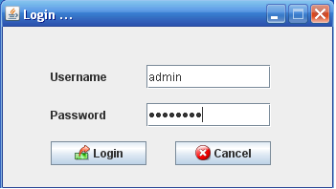

**Add New User**

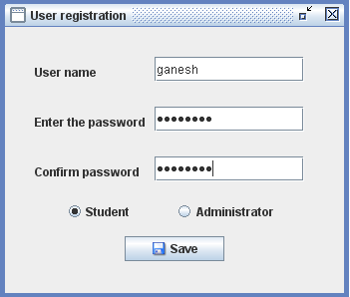

**Edit User Type**

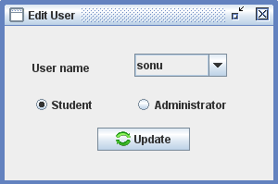

**Delete User**

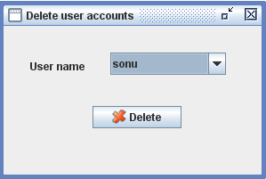

**Student Registration**

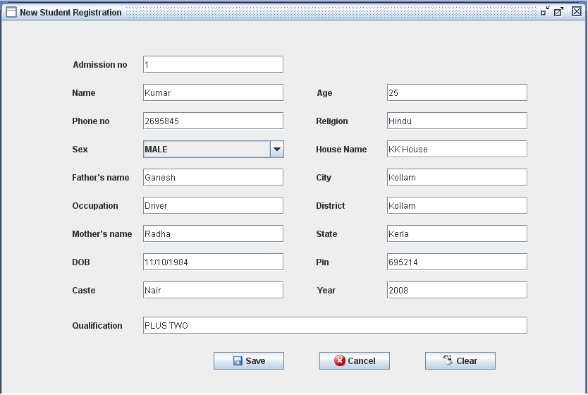

**Edit Student Details**

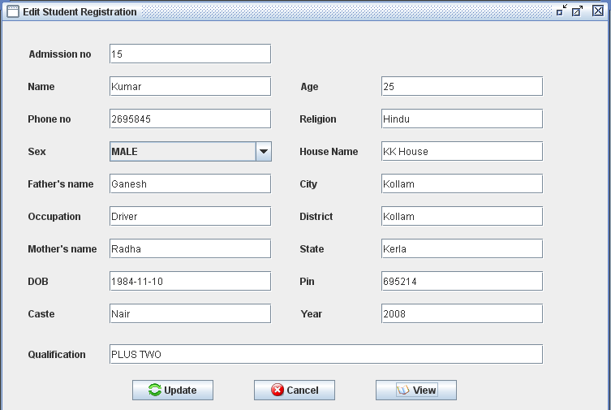

**Delete Student details**

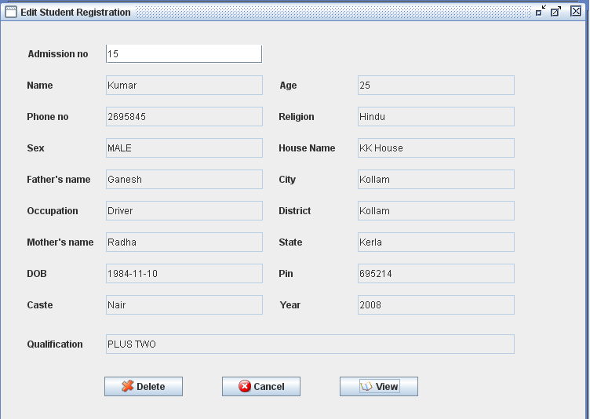

**Add/Edit Mark Details**

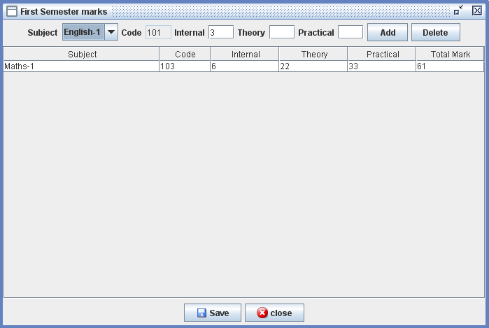

**View Marks**

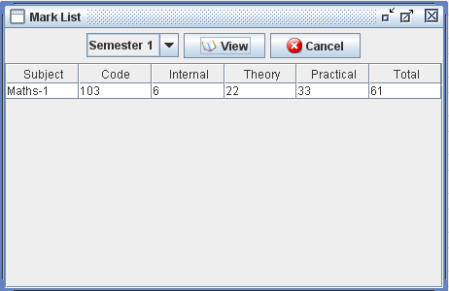

**View User details**

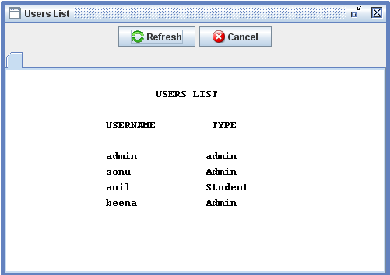

**View Student Details**

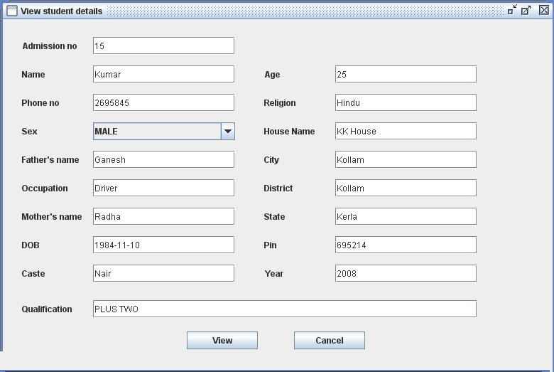

**Add New Subjects**

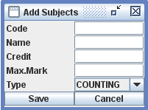

**Edit Subject details**

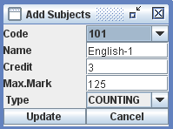

**Delete Subject details**

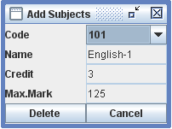

**Subject Allocation**

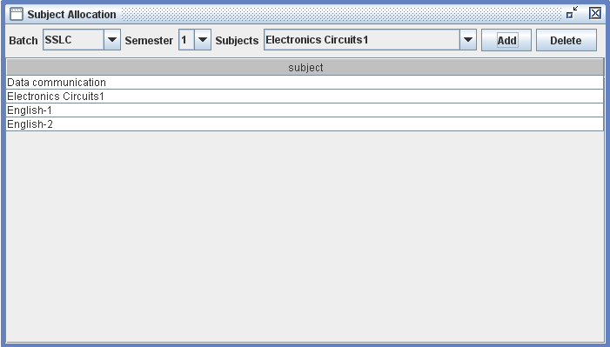

**10. Benefits of Student Management System.**

* Simplifying &streamlining all Tasks.
* Complete Tracking of the Students.
* More secure

**Limitations:**

1)In Some movement some Glitches are there.

2)Difficult to access students out of network;

**11.Future Enhancement**

The Future enhancement to the student management system is we can convert this system to Online Student Management System .We can add new Technologies like Machine learning and Add Artificial Intelligence to this system to automated the data and Many new future can added to this system .

**12. CONCLUSION:**

In this project the students are Managed Very Easily. This is efficient to manage student management system . This is very secure system because this system is worked on LAN .In this project two entity can operate . The main entity is admin which can manipulate the data he create user delete user register student add marks edit marks add subject delete subject edit subject and allocate the subject .The student entity is another or secondary he can view its student detail, marks details this system is efficient future enactment can be possible in this system which an automate this project.

**13. Bibliography**

**Books**

1. Java and Software Design Concepts by APress
2. *Database Programming with JDBC and Java by O'Reilly*
3. Head First Java 2nd Edition

**Website**

1. <http://www.jdbc-tutorial.com/>
2. <http://www.javaworld.com/javaworld/>